#### **Website UI Testing**

| **Issue ID** | **Issue Description** | **Steps to Reproduce** | **Expected Result** | **Actual Result** |
| --- | --- | --- | --- | --- |
| 001 | Extra Drop Down icon | 1.Open homepage  2.Check header section | There should not be any drop down icon. | Extra drop down icon found. |

Expected Screenshot:

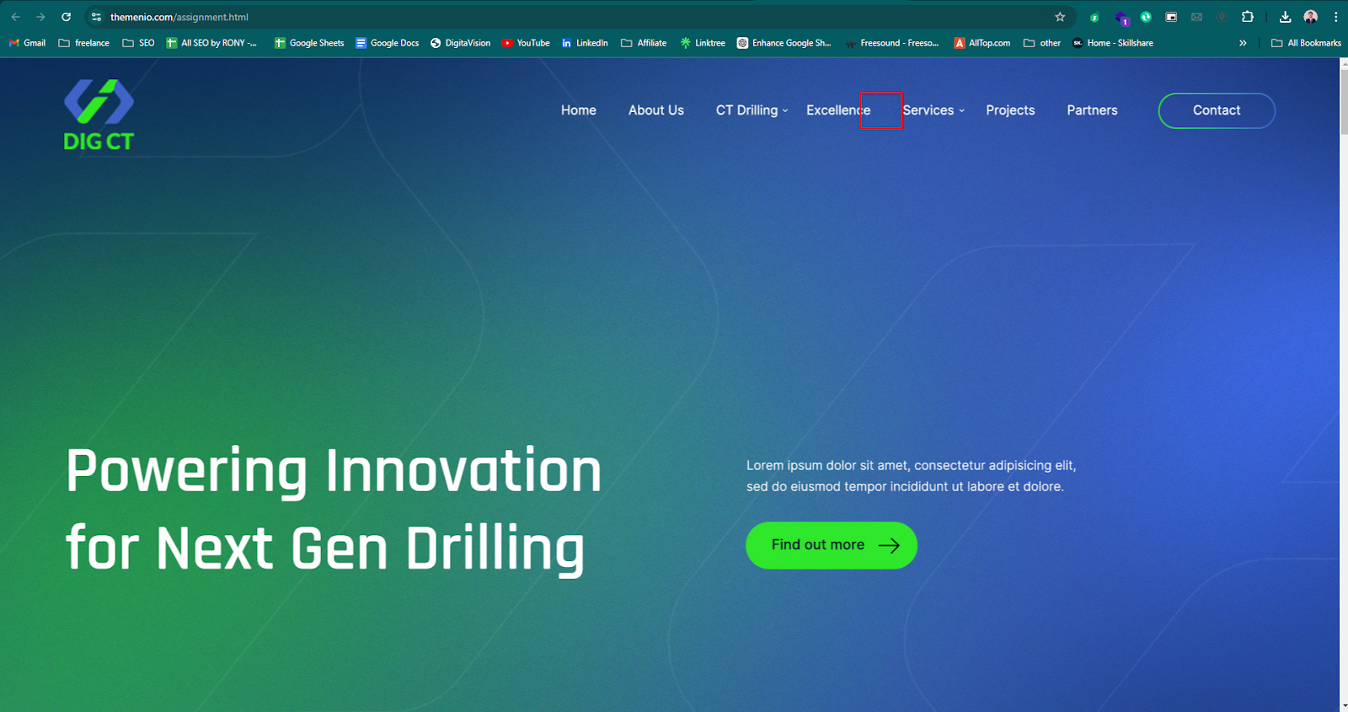

Actual Screenshot:

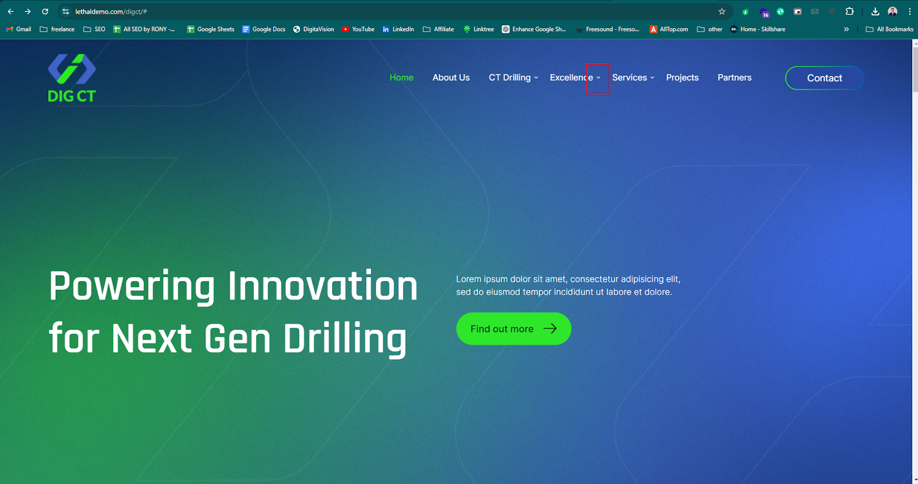

| **Issue ID** | **Issue Description** | **Steps to Reproduce** | **Expected Result** | **Actual Result** |
| --- | --- | --- | --- | --- |
| 002 | Links are not working | 1.Open homepage  2.Hover over CT Drilling option  3.Click on a link in the dropdown. | Links should redirect to correct pages. | Links in the dropdown do not respond. |

Screenshot: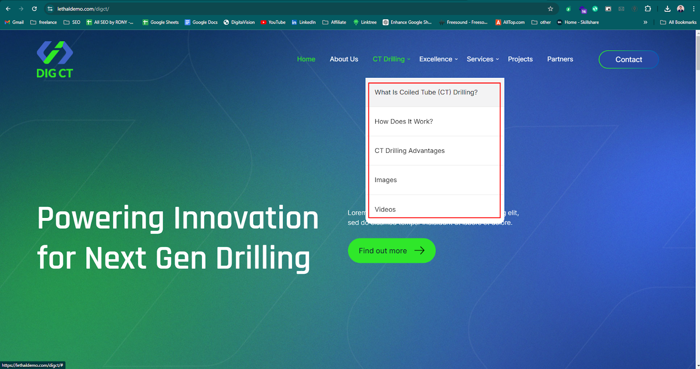

| **Issue ID** | **Issue Description** | **Steps to Reproduce** | **Expected Result** | **Actual Result** |
| --- | --- | --- | --- | --- |
| 003 | Links are not working | 1.Open homepage  2.Scroll down  3.Hover and click Learn more action | Links should redirect to correct pages. | Links do not respond. |

Screenshot:

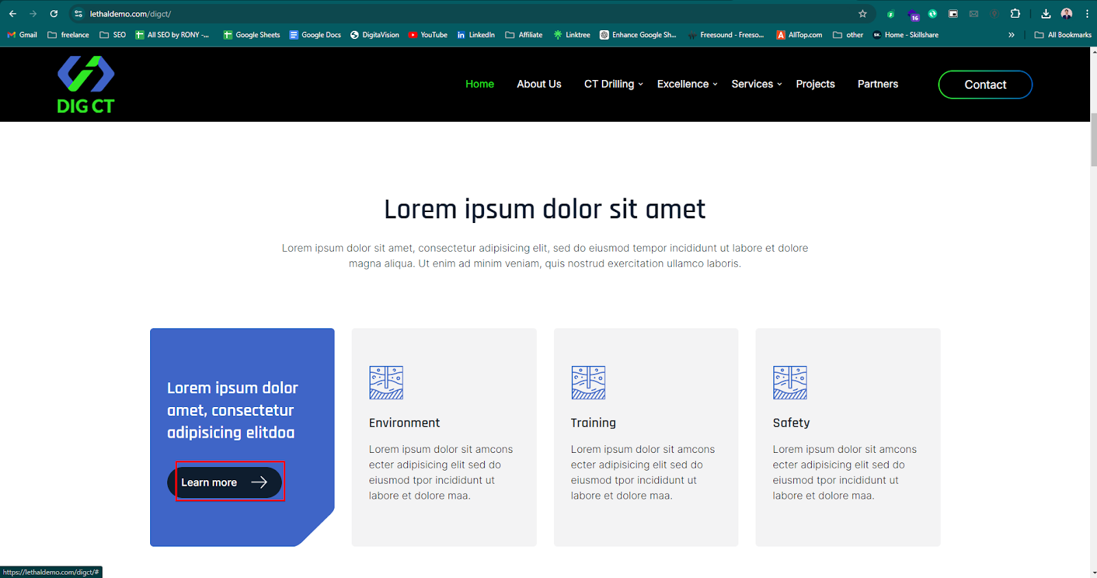

| **Issue ID** | **Issue Description** | **Steps to Reproduce** | **Expected Result** | **Actual Result** |
| --- | --- | --- | --- | --- |
| 004 | Extra text appears in the hover state in feature cards. | 1.Open homepage  2.Scroll down and hover in feature cards. | Only the design specified text should display. | More text than what is shown in the design |

Expected Screenshot:

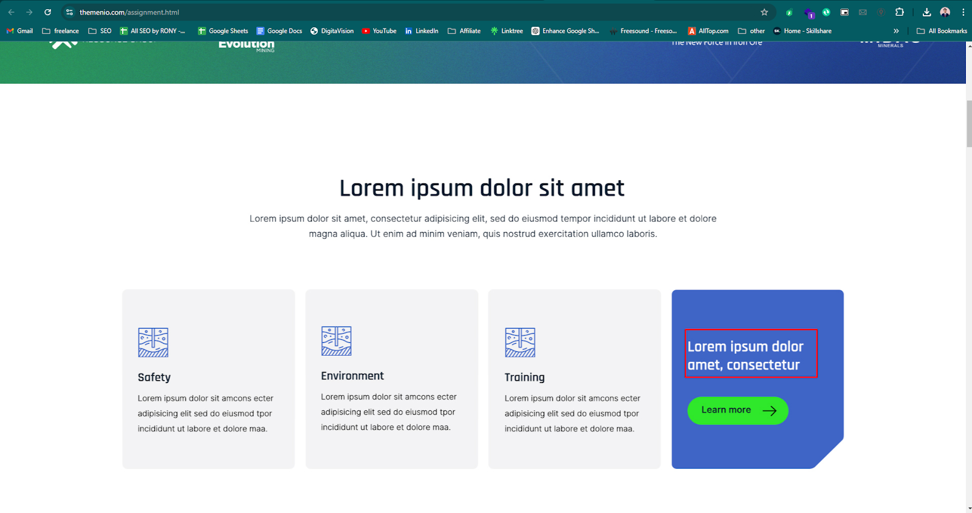

Actual Screenshot:

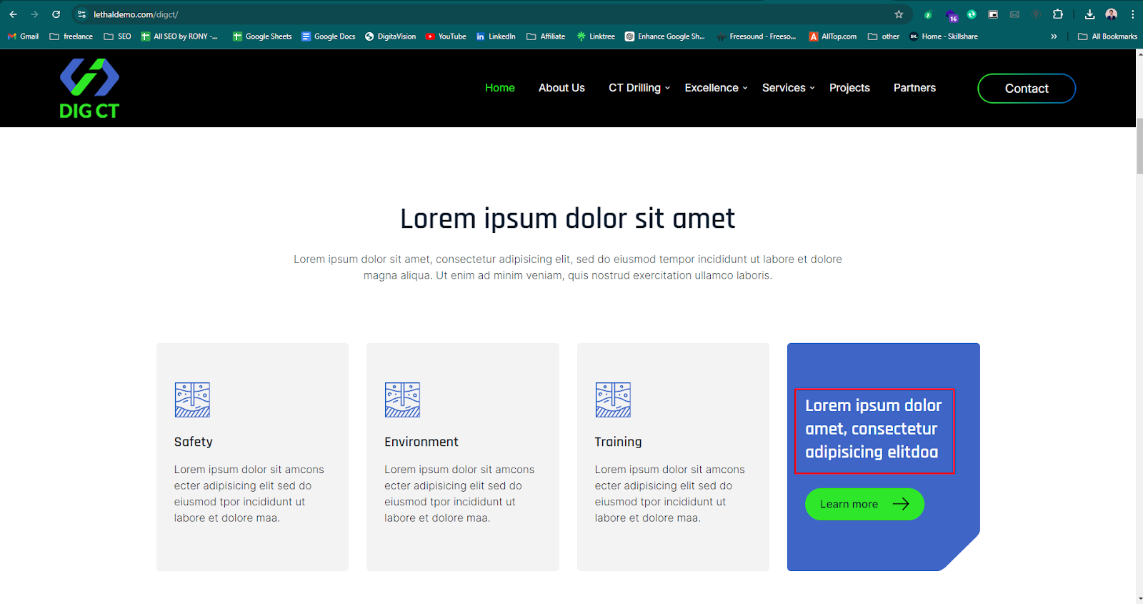

| **Issue ID** | **Issue Description** | **Steps to Reproduce** | **Expected Result** | **Actual Result** |
| --- | --- | --- | --- | --- |
| 005 | Card description text overflowing. | 1. Open the homepage.  2. Scroll to the section with the feature cards. | Each card description should fit within three lines as per the design. | The description in the feature cards is taking up four lines. |

Expected Screenshot:

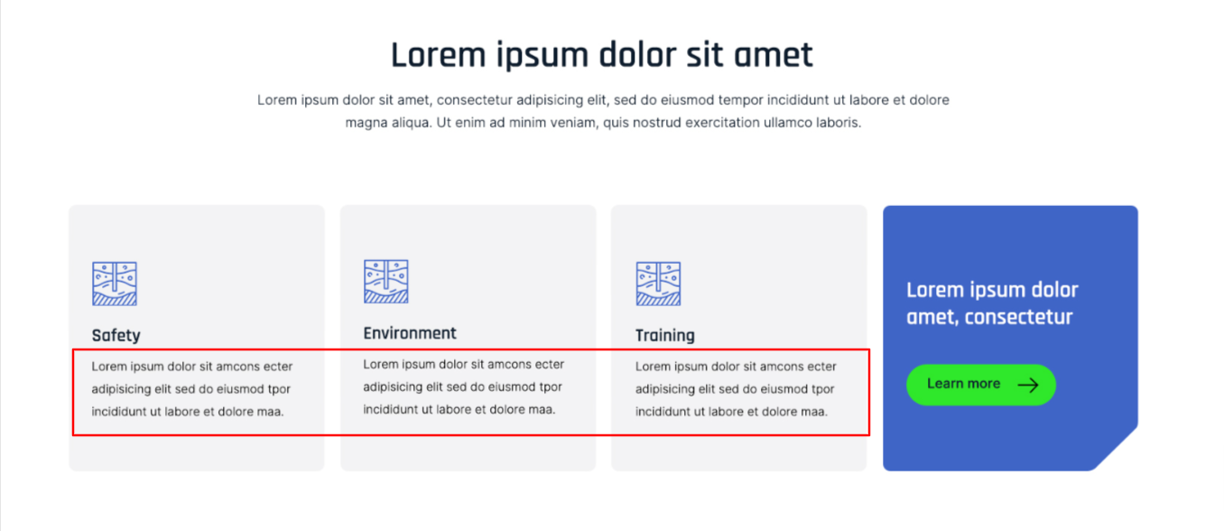

Actual Screenshot:

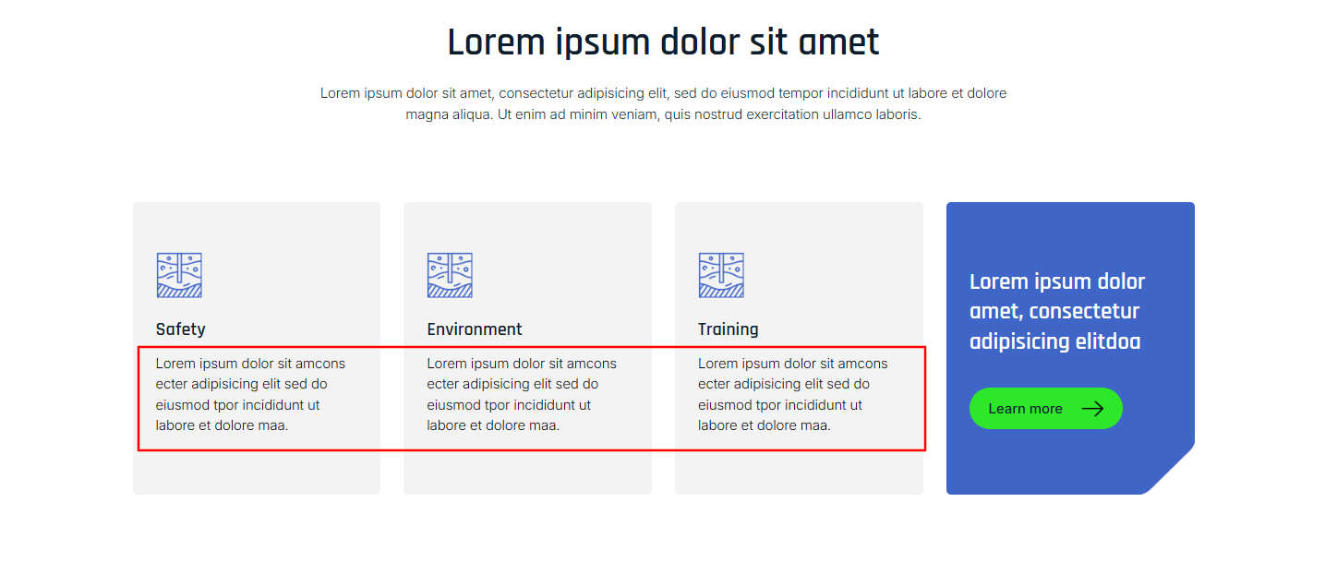

| **Issue ID** | **Issue Description** | **Steps to Reproduce** | **Expected Result** | **Actual Result** |
| --- | --- | --- | --- | --- |
| 006 | Line spacing is higher than the design | 1. Open the homepage.  2. Scroll to the section shown in the screenshot.. | The line spacing should be as per the design. | The line spacing in the bold text block is higher compared to the design. |

Expected Screenshot:

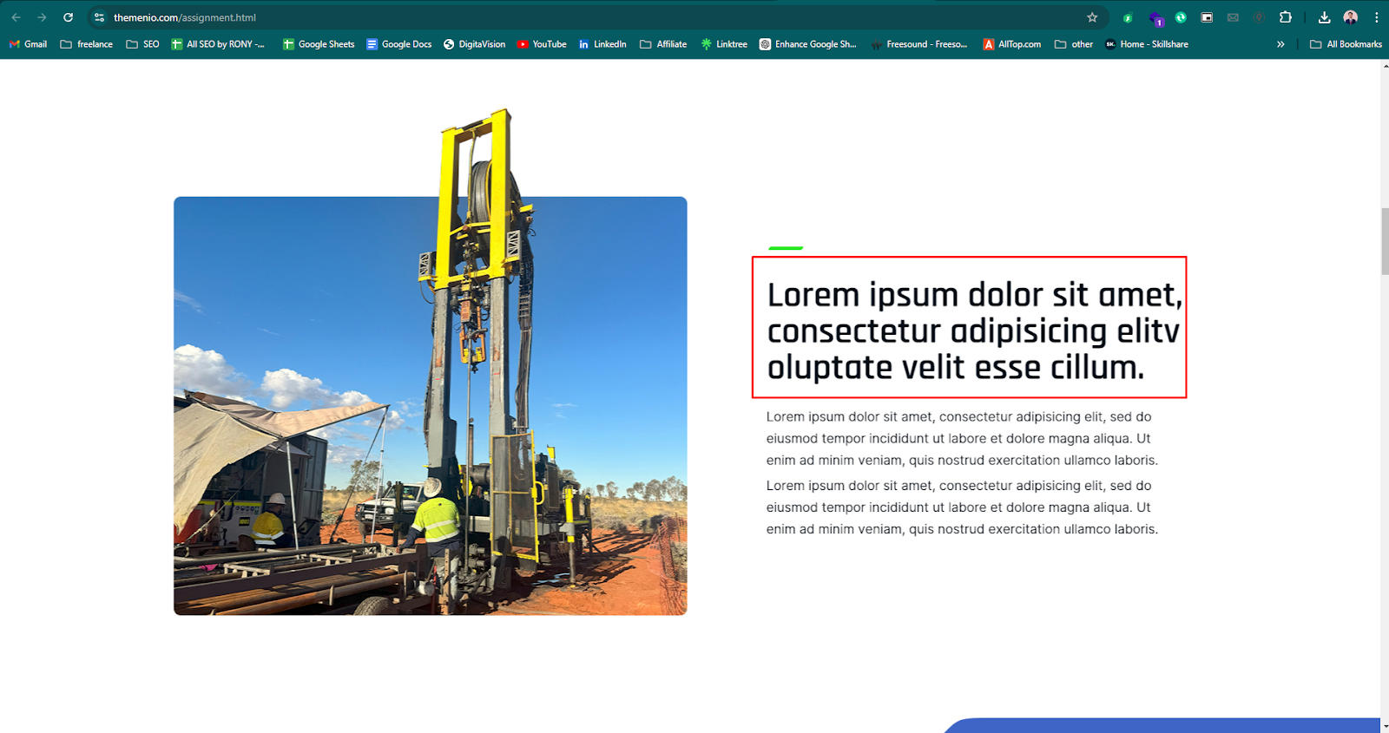

Actual Screenshot:

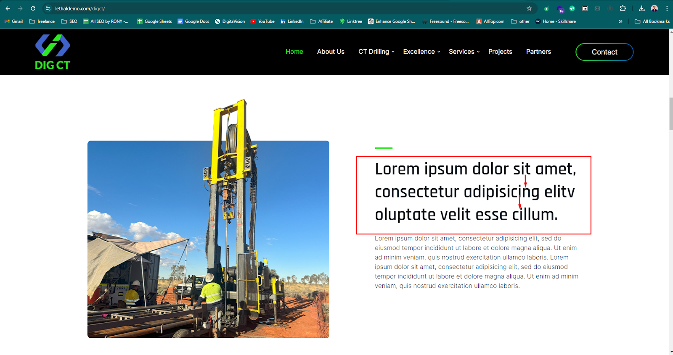

| **Issue ID** | **Issue Description** | **Steps to Reproduce** | **Expected Result** | **Actual Result** |
| --- | --- | --- | --- | --- |
| 007 | Font weight are inconsistent with the design | 1. Open the homepage.  2. Scroll to the section shown in the screenshot.. | The font weight should match the design. | Font weight and alignment is not matched with the design. |

Expected Screenshot:

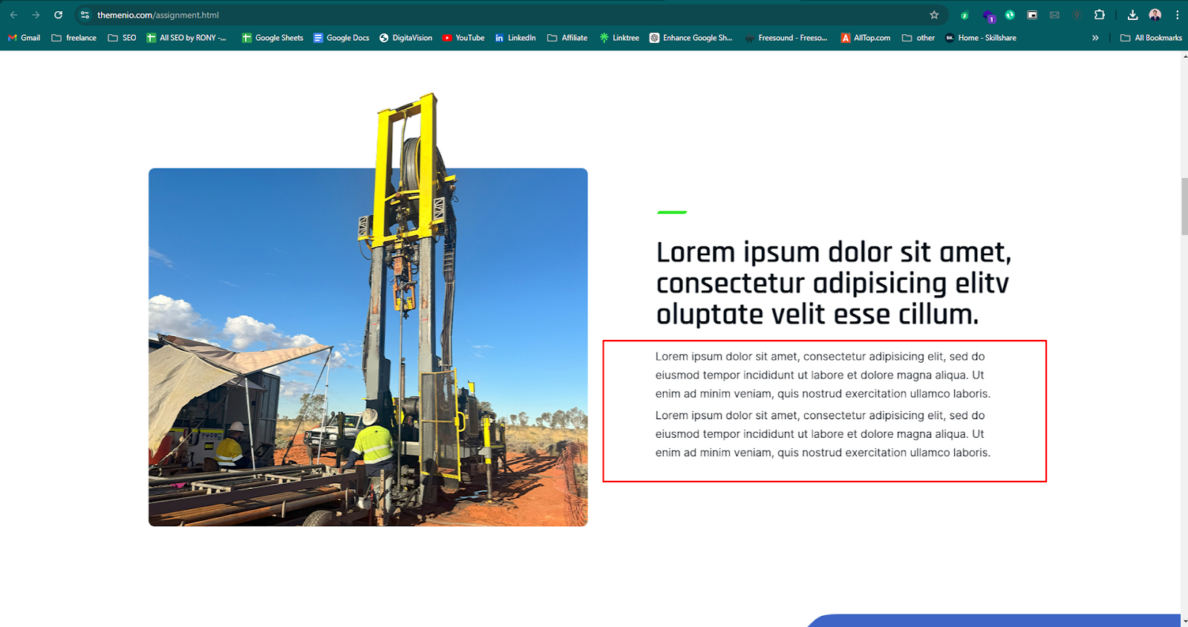

Actual Screenshot:

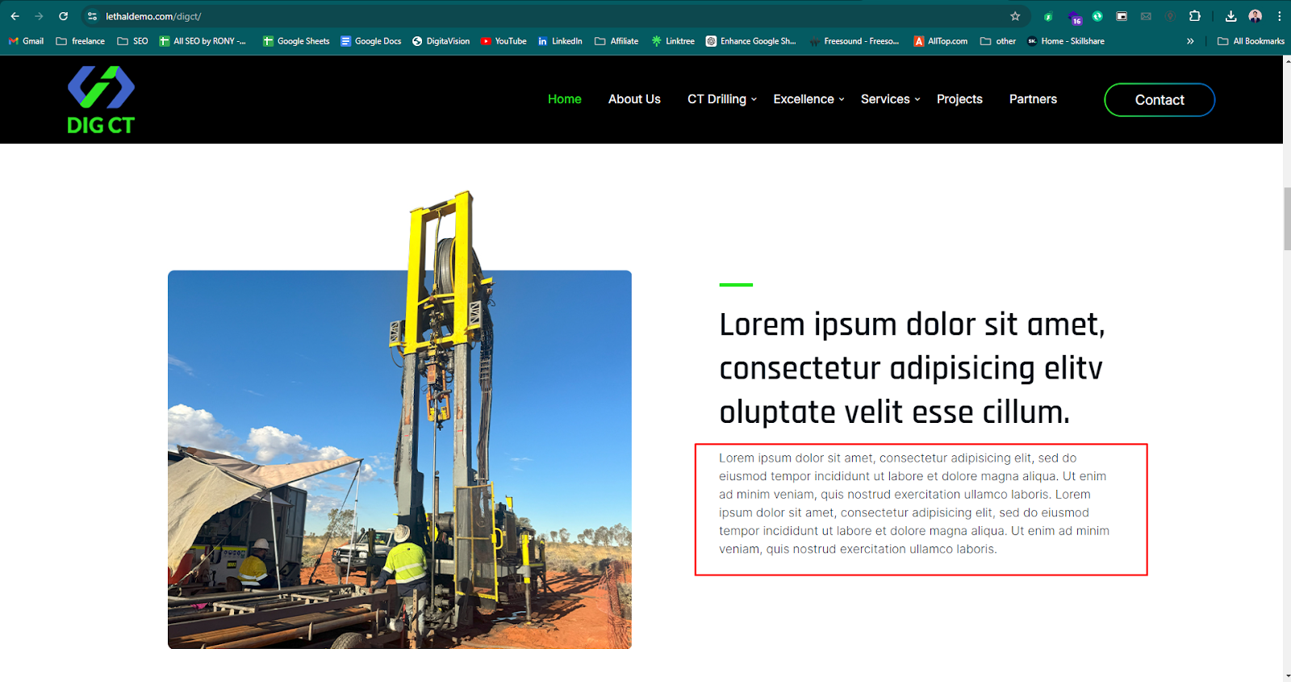

| **Issue ID** | **Issue Description** | **Steps to Reproduce** | **Expected Result** | **Actual Result** |
| --- | --- | --- | --- | --- |
| 008 | Line breaks and text distribution do not match | 1. Open the homepage.  2. Scroll to the section shown in the screenshot. | Lines should break as per the design, ensuring balanced distribution. | The line breaks are uneven, and the text is not distributed properly, |

Expected Screenshot:

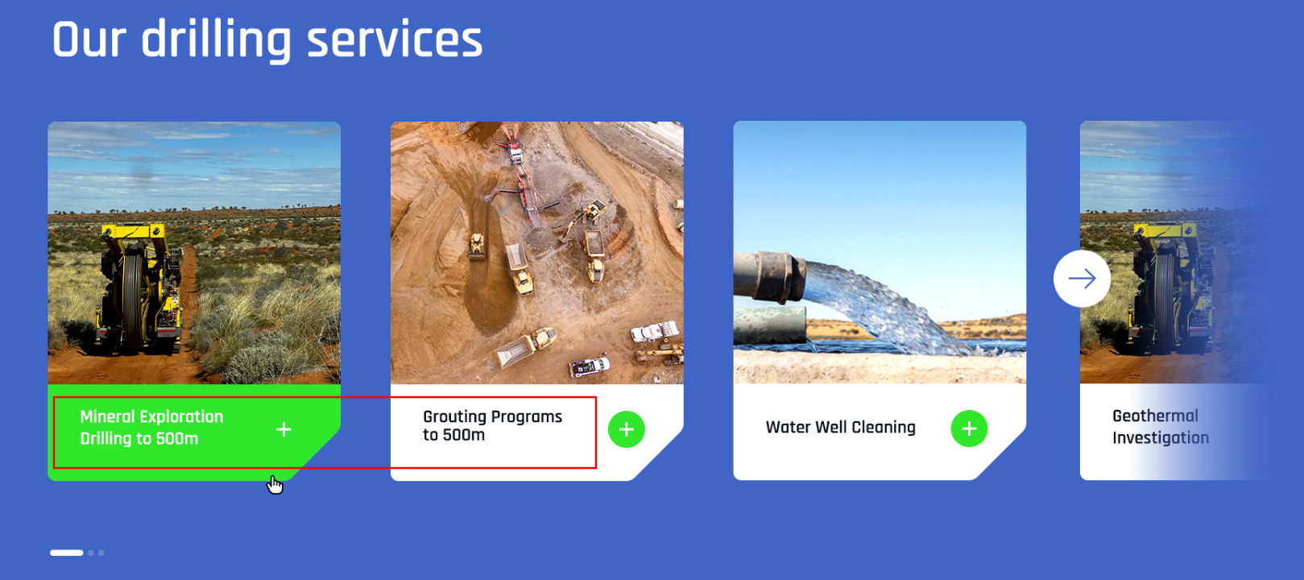

Actual Screenshot:

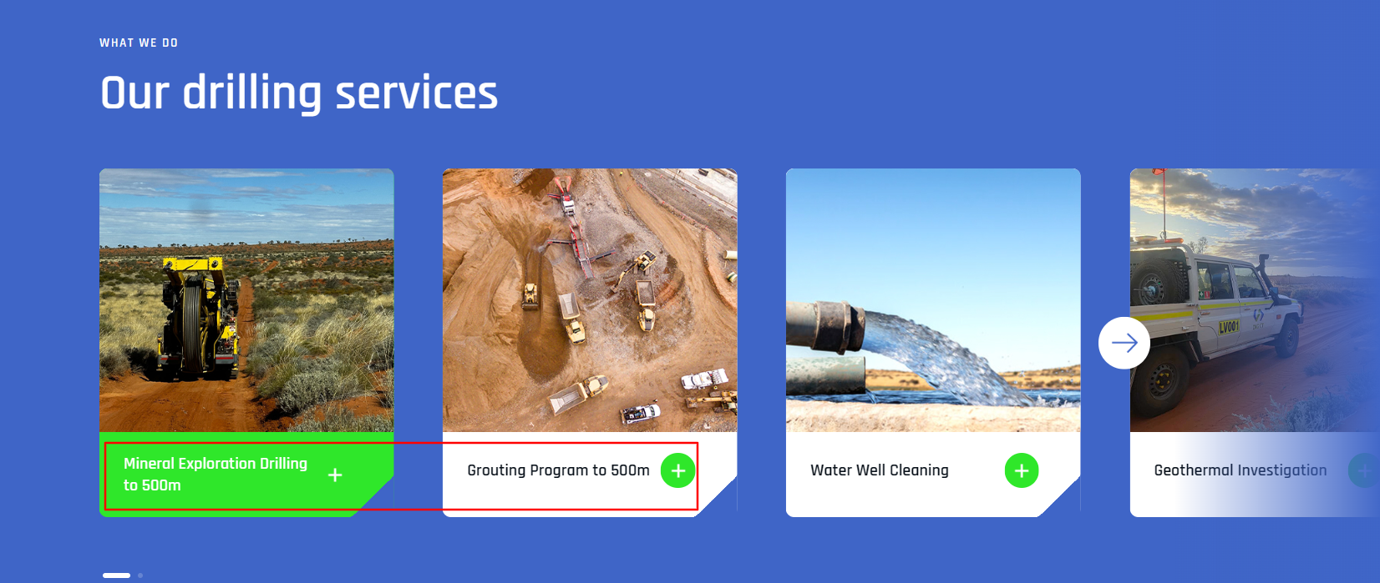

| **Issue ID** | **Issue Description** | **Steps to Reproduce** | **Expected Result** | **Actual Result** |
| --- | --- | --- | --- | --- |
| 009 | Mismatch in Carousel Icons. | 1. Open the homepage.  2. Scroll to the section shown in the screenshot. | Three icons should be displayed in the carousel as per the design. | Only two are displayed in the actual implementation |

Expected Screenshot:

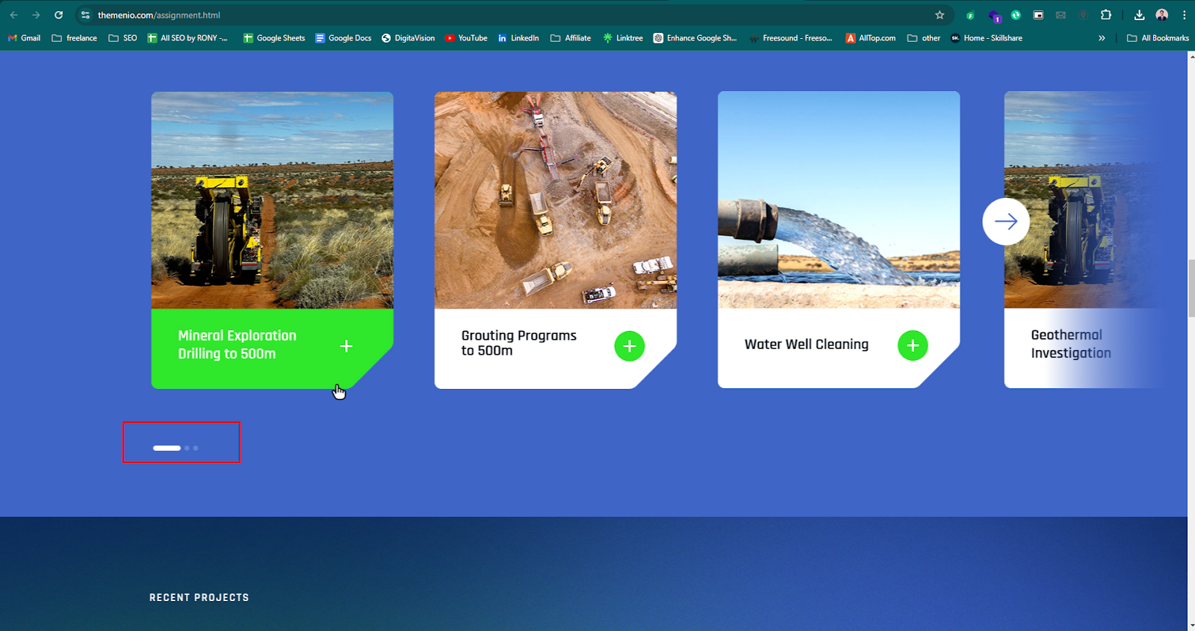

Actual Screenshot:

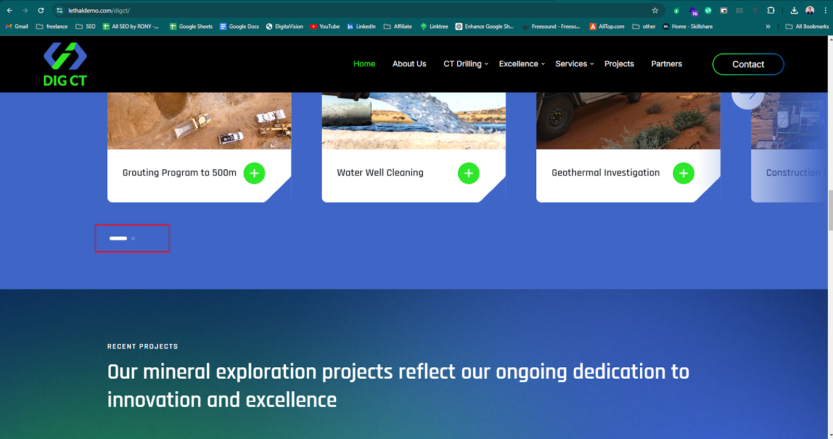

| **Issue ID** | **Issue Description** | **Steps to Reproduce** | **Expected Result** | **Actual Result** |
| --- | --- | --- | --- | --- |
| 010 | Line breaks and text distribution do not match | 1. Open the homepage.  2. Scroll to the section shown in the screenshot. | Lines should break as per the design, ensuring balanced distribution. | The line breaks are uneven, and the text is not distributed properly, |

Expected Screenshot:

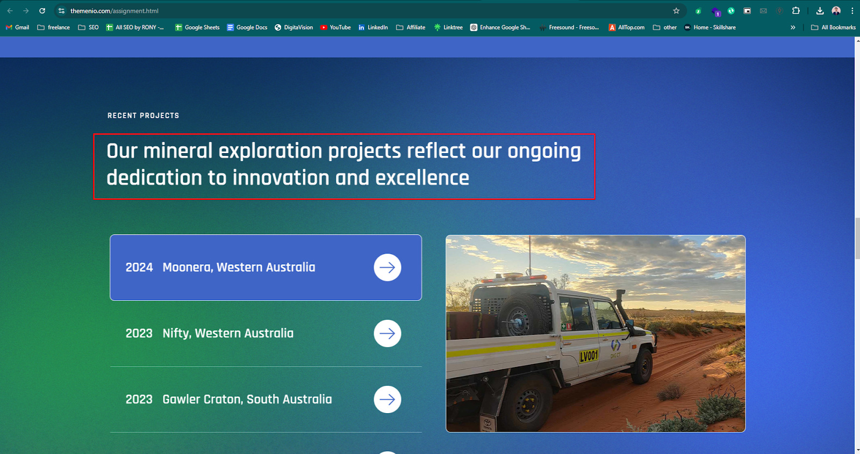

Actual Screenshot:

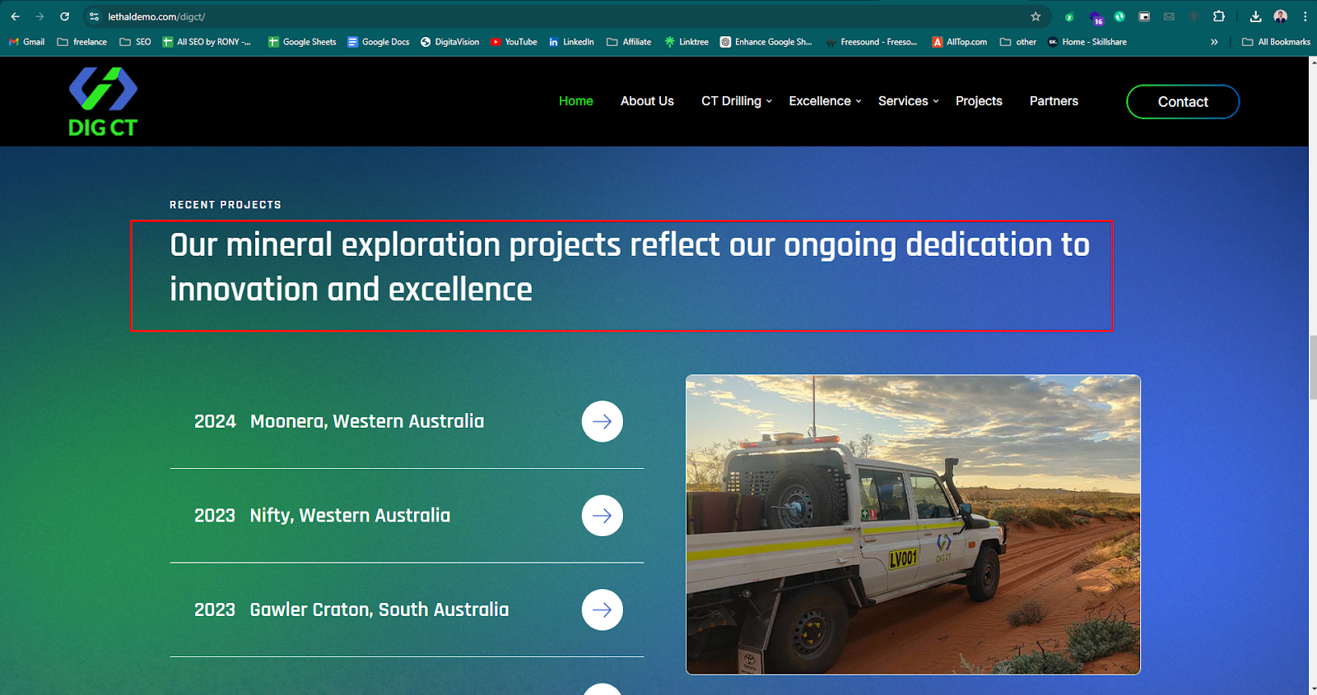

| **Issue ID** | **Issue Description** | **Steps to Reproduce** | **Expected Result** | **Actual Result** |
| --- | --- | --- | --- | --- |
| 011 | Content description line mismatched. | 1. Open the homepage.  2. Scroll to the section shown in the screenshot. | Here description should fit within two lines as per the design. | The description in the feature cards is taking up three lines. |

Expected Screenshot:

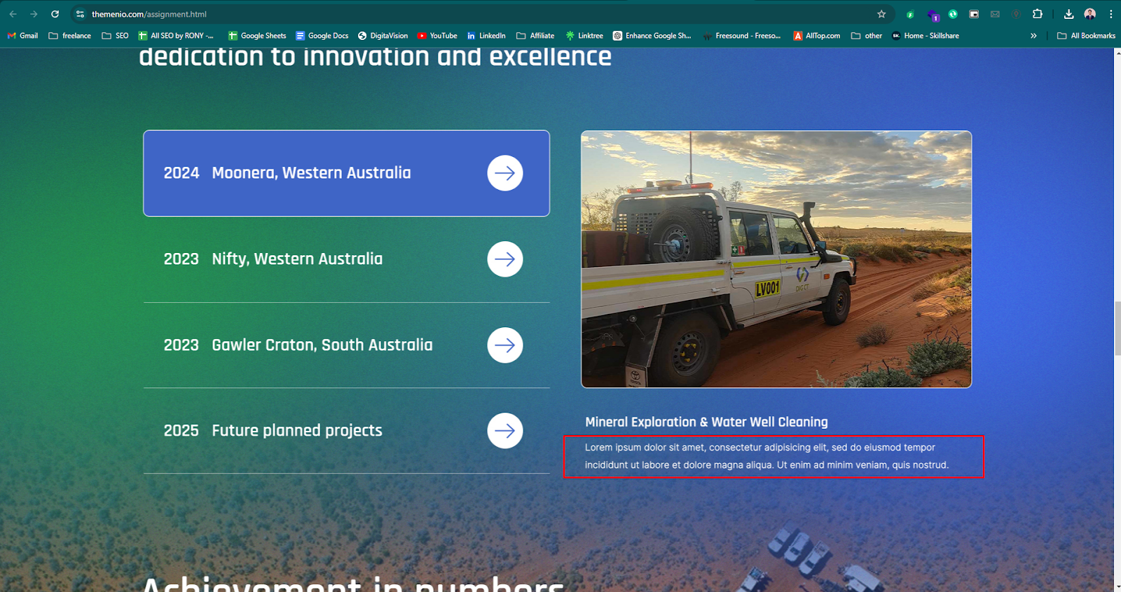

Actual Screenshot:

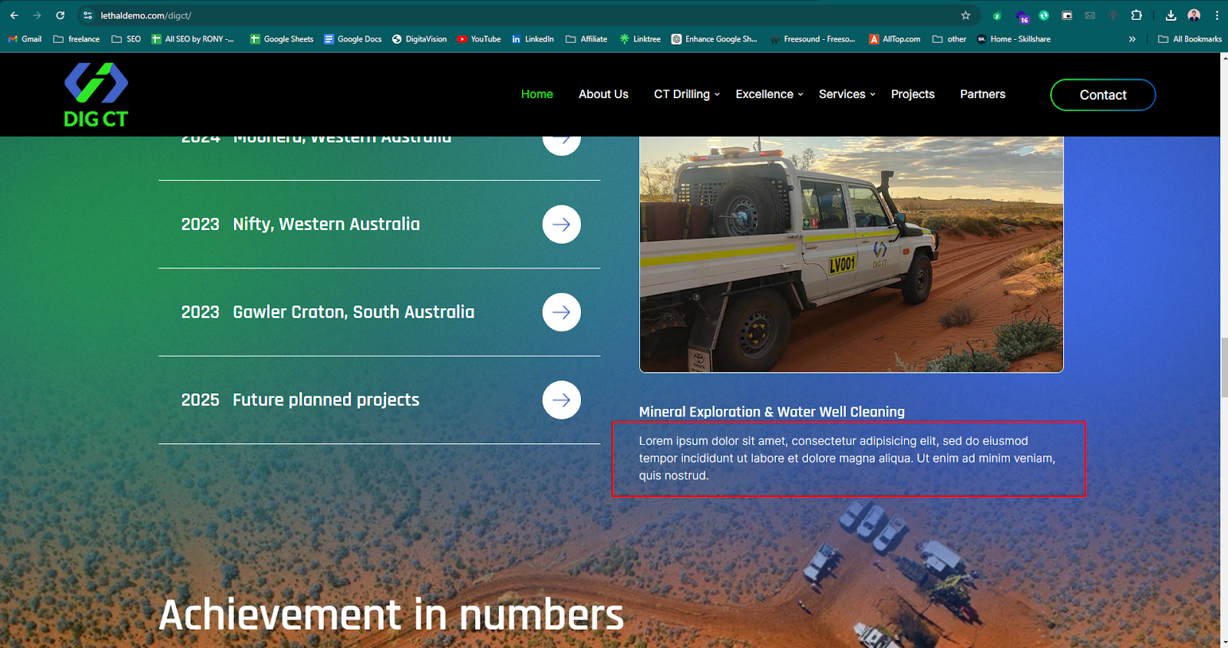

| **Issue ID** | **Issue Description** | **Steps to Reproduce** | **Expected Result** | **Actual Result** |
| --- | --- | --- | --- | --- |
| 012 | Inconsistent Number Alignment in boxes. | 1. Open the homepage.  2. Scroll to the section shown in the screenshot. | The numbers '200+' in are not aligned consistently across the three boxes. | The number in the second box is positioned higher than the other numbers in the box. |

Expected Screenshot:

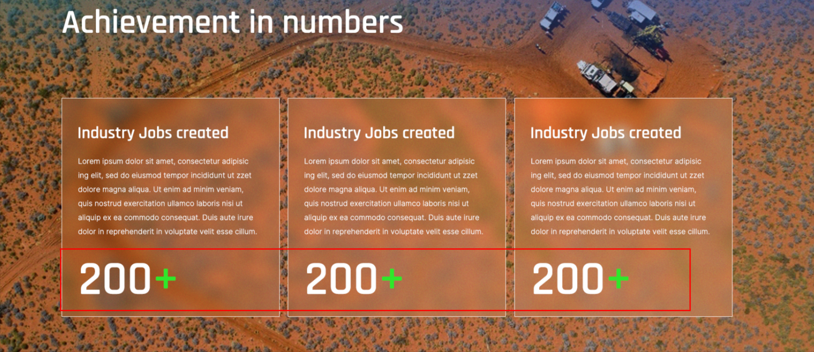

Actual Screenshot:

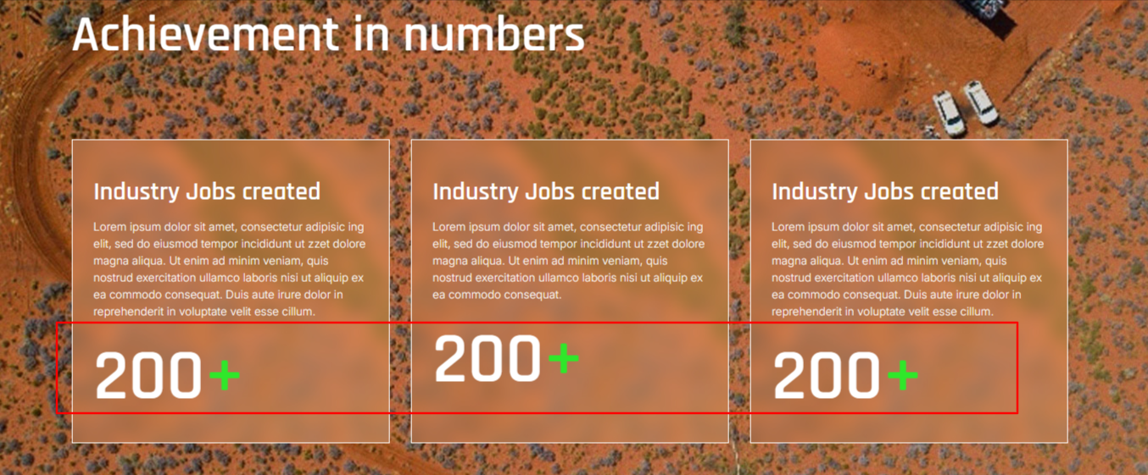

| **Issue ID** | **Issue Description** | **Steps to Reproduce** | **Expected Result** | **Actual Result** |
| --- | --- | --- | --- | --- |
| 013 | Social Links Not Functioning | 1. Open the homepage.  2. Scroll to the section shown in the screenshot.  3.Click on any of the social media icons. | Clicking on the social media icons should redirect to the respective social media pages | Links are not working. |

Screenshot:

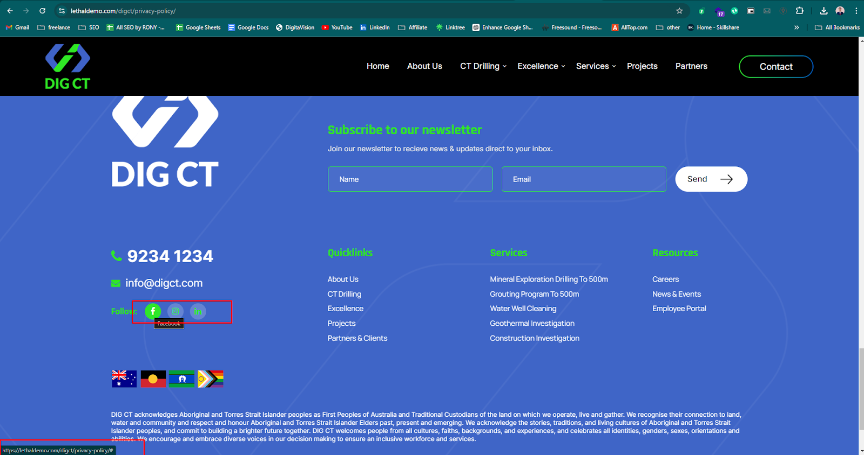

| **Issue ID** | **Issue Description** | **Steps to Reproduce** | **Expected Result** | **Actual Result** |
| --- | --- | --- | --- | --- |
| 014 | Inconsistent Icon Weight in Contact Information Section | 1. Open the homepage.  2. Scroll to the section shown in the screenshot. | The icons have varying weights, causing some to appear bolder than others. | The icon weight does not match with the design. |

Expected Screenshot: Actual Screenshot:

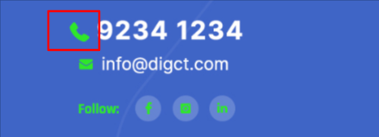

| **Issue ID** | **Issue Description** | **Steps to Reproduce** | **Expected Result** | **Actual Result** |
| --- | --- | --- | --- | --- |
| 015 | Content mismatch Issue | 1. Open the homepage.  2. Scroll to the section shown in the screenshot. | The marked content should match the original description accurately | Content does not match with the original description. |

Expected Screenshot:

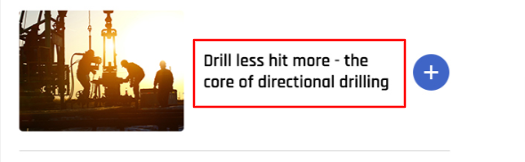

Actual Screenshot:

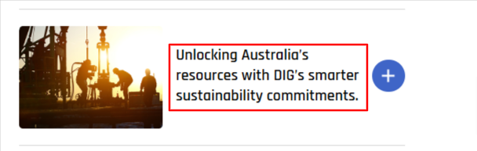

| **Issue ID** | **Issue Description** | **Steps to Reproduce** | **Expected Result** | **Actual Result** |
| --- | --- | --- | --- | --- |
| 016 | Content Justification Alignment Issue | 1. Open the homepage.  2. Scroll to the footer section shown in the screenshot. | The text content should be justified and aligned uniformly. | The text content is not justified properly, resulting in a misaligned appearance. |

Expected Screenshot:

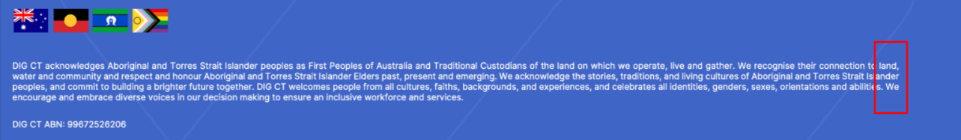

Actual Screenshot:

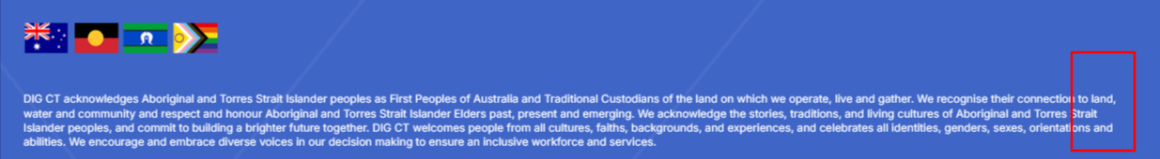

| **Issue ID** | **Issue Description** | **Steps to Reproduce** | **Expected Result** | **Actual Result** |
| --- | --- | --- | --- | --- |
| 017 | Duplicate Content Display | 1. Open the homepage.  2. Scroll to the blog section shown in the screenshot. | Each piece of content should be unique and not repeated as per design. | The same content is being displayed twice |

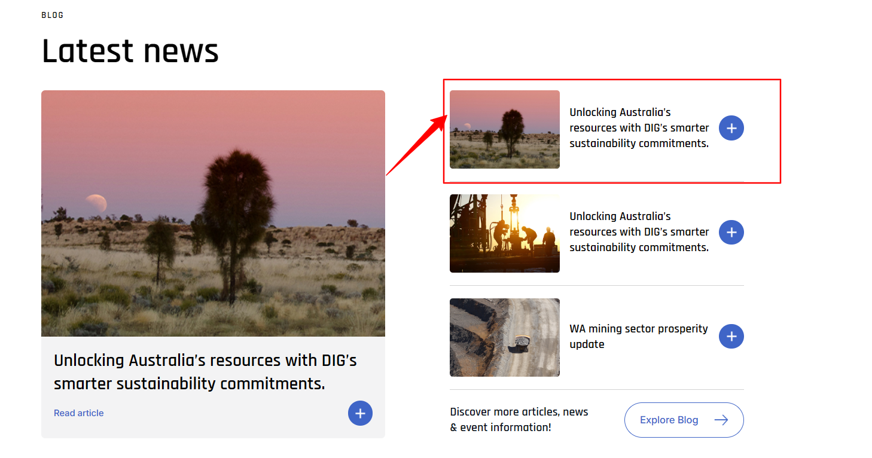

| **Issue ID** | **Issue Description** | **Steps to Reproduce** | **Expected Result** | **Actual Result** |
| --- | --- | --- | --- | --- |
| 018 | Extra Space in Responsive Design | 1. Open the homepage on different devices.  2.Navigate to the header area.  3.Observe the extra space. | The header area should adapt smoothly to different screen sizes | The header area contains noticeable extra space that disrupts the layout. |

Screenshot:

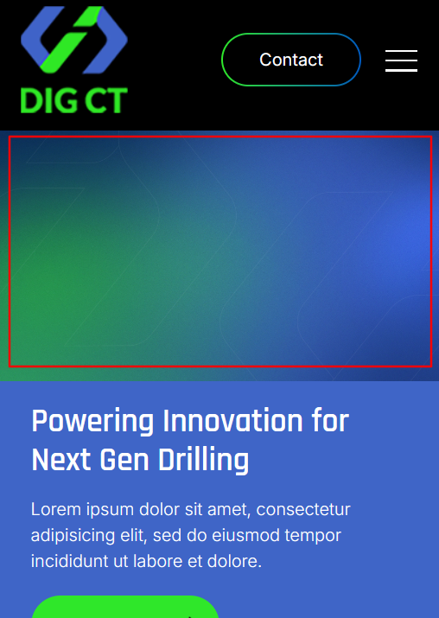

| **Issue ID** | **Issue Description** | **Steps to Reproduce** | **Expected Result** | **Actual Result** |
| --- | --- | --- | --- | --- |
| 019 | Image Clarity Issue | 1. Open the homepage.  2. Scroll to the section shown in the screenshot. | The promotional image for drilling services should be clear with all text and visuals | The image appears blurry and unclear. |

Screenshot:

